Project Name: News App

**Project Team Members:**

1.**Name**: v.Lekhamithra

**Email**: lekhamithravijayakumark22@gmail.com

2.**Name**: Pavithra.M

**Email**: Pavithramunusamy249@gmail.com

3.**Name**: Nirmal.S

**Email**:Nirmalanithya07@gmail.com

4.**Name**: V.Monishree

**Email**: Deepalakshmid68@gmail.com

InsightStream: Navigate the News

Landscape **(React Application)**

# Introduction:

# InsightStream is a revolutionary web application designed to redefine how people discover and consume news. It offers an intuitive interface, dynamic search, and a vast range of news categories for all types of users. Join InsightStream to embark on an informative journey and experience the future of news consumption.

# React application designed to help users easily navigate the ever-changing and overwhelming news landscape. In today’s fast-paced world, staying informed is more crucial than ever, but it can often be challenging to filter through the noise and find relevant, trustworthy information. **InsightStream** aims to solve this by providing a streamlined, user-friendly platform where you can explore the latest headlines, trends, and in-depth stories tailored to your interests.

# With a focus on **personalization**, **real-time updates**, and **data-driven insights**, InsightStream empowers users to gain a deeper understanding of current events, track ongoing stories, and explore news from diverse sources and perspectives. Whether you're looking to follow global affairs, local updates, or niche topics, InsightStream is your ultimate tool to stay connected and informed, all in one place.

# Description:

* Welcome to the cutting-edge frontier of news exploration with InsightStream! Our revolutionary web application is meticulously crafted to transcend the boundaries of traditional news consumption, catering to the diverse interests of both avid news enthusiasts and seasoned information professionals. With an emphasis on an intuitive user interface and a robust feature set, InsightStream is poised to redefine the entire news discovery and consumption process.
* Designed with a commitment to user-friendly aesthetics, InsightStream immerses users in an unparalleled journalistic adventure. Navigate seamlessly through a vast expanse of news categories with features such as dynamic search, effortlessly bringing you the latest and most relevant stories from around the world.
* From those seeking the latest headlines to seasoned news connoisseurs, InsightStream embraces a diverse audience, fostering a dynamic community united by a shared passion for staying informed. Our vision is to reshape how users interact with news, presenting a platform that not only delivers breaking stories but also encourages collaboration and sharing within the vibrant news community.
* Embark on this informative journey with us, where innovation seamlessly intertwines with journalistic tradition. Every click within InsightStream propels you closer to a realm of global happenings and perspectives. Join us and experience the evolution of news consumption, where each feature is meticulously crafted to offer a glimpse into the future of staying informed.
* Elevate your news exploration with InsightStream, where every headline becomes a gateway to a world of information waiting to be discovered and understood. Trust InsightStream to be your reliable companion on the journey of staying connected with the pulse of the world.

# Scenario Based Intro:

Suppose you're rushing home after work, phone clutched in your hand. Today's been a whirlwind, and you have no idea what's happening in the world. Suddenly, you remember InsightStream , the innovative app you downloaded that promised to revolutionize your news experience. Intrigued, you open the app. Images flash across the screen – breaking headlines, in-depth articles, diverse categories. This isn't your typical news feed. InsightStream feels...different. Intrigued, you tap a category and dive in, ready to explore the future of staying informed.

**Scenario 1: The Busy Professional**

Imagine you're a busy professional, juggling multiple projects and meetings. You know staying updated on current events is essential, but you don’t have the time to sift through countless articles or scroll through social media.

**Scenario 2: The Student Researcher**

As a student, you're working on an important research paper, and you need access to credible and relevant news sources. Traditional news sites may bombard you with irrelevant content, while social media often blurs the line between fact and fiction.

**Scenario 3: The Casual News Enthusiast**

You’re a casual news consumer—someone who wants to stay informed, but you don’t have hours to dedicate to reading the paper or watching the news on TV. You simply want to catch up on the day's top stories and explore topics that spark your curiosity.

**Scenario 4: The Global Citizen**

You’re passionate about global events and love staying informed about news from different corners of the world. However, keeping track of international news can feel overwhelming with so many different time zones, languages, and sources.

# Technicsal Architecture:

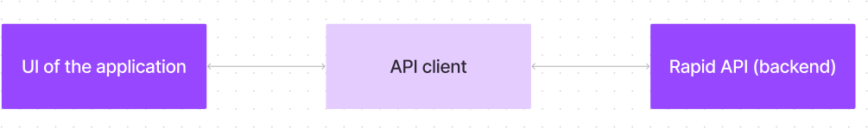

The user experience starts with the InsightStream web application's UI, likely built with a framework like React or Vue.js for a smooth, single-page experience. This UI interacts with an API client specifically designed for InsightStream. This client handles communication with the backend, but with a twist: it leverages Rapid API, a platform providing access to various external APIs. This suggests InsightStream might integrate external data feeds or functionalities through Rapid API, enriching the user experience without building everything from scratch.

**1. Frontend - UI of the Application:**

* Developed using React.js for an interactive and responsive user interface.
* Uses React Router for seamless navigation between different news categories.
* Incorporates state management (e.g., Redux or Context API) to handle user preferences and API data.
* Supports dark mode and accessibility features for an improved reading experience.

**2. API Client - Data Fetching & Processing:**

* Communicates with Rapid API to fetch real-time news from various external sources.
* Uses Axios or Fetch API for making HTTP requests efficiently.
* Implements debouncing and caching to reduce unnecessary API calls and optimize performance.
* Supports real-time filtering and sorting of news based on user preferences (e.g., trending, category, region).

**3. Backend - Rapid API (News Data Provider):**

* Instead of a traditional backend, InsightStream leverages Rapid API to fetch news from multiple sources like NewsAPI, Bing News Search, or NYTimes API.
* Implements API authentication using API keys to ensure secure access to data.
* Uses server-side pagination and rate limiting to optimize API usage and prevent excessive requests.

**4. Additional Features & Enhancements:**

* Personalized News Feed – AI-powered recommendations based on user reading history.
* Sentiment Analysis – Using AI or third-party APIs to analyze news sentiment (positive, neutral, or negative).
* Multilingual Support – Integrating translation APIs for global news consumption.
* Offline Mode – Service Workers to cache news articles for offline reading.

# Project Goals and Objectives:

The primary objective of InsightStream is to establish a user-friendly platform tailored for individuals who are passionate about staying informed, exploring diverse news topics, and accessing the latest updates.

**key goals include:**

* + - **User-Friendly Experience:** Develop an interface that is intuitive and easy to navigate, ensuring users can effortlessly access, save, and share their preferred news articles.
    - **Comprehensive News Management:** Provide robust features for organizing and managing news content, incorporating advanced search options for a personalized news experience.
    - **Technology Stack:** Employ cutting-edge web development technologies, such as React.js, to ensure an efficient and enjoyable user interface.

### ****Build an Intuitive User Interface:**** Design a user-friendly, visually appealing interface for navigating news stories, trends, and updates. This should include interactive components like search bars, filters, and content categorization to ensure users can easily find and explore articles of interest.

### ****Integrate Real-Time News Data:****Integrate a reliable news API (such as NewsAPI, Google News, or custom backend service) to deliver real-time, up-to-date news content. The React app should handle dynamic data fetching, including pagination or infinite scrolling, and present the news in an easily digestible format.

### ****Support User Personalization:**** Enable user customization features, such as saving favorite news sources, articles, or topics. Additionally, offer the ability to personalize the news feed based on interests, viewing history, or other preferences (e.g., dark mode, article layout).

### ****Optimize Performance and Mobile Responsiveness:****Ensure that the React application is optimized for performance, especially for mobile users. This includes fast loading times, smooth transitions, and mobile-first design principles, making it accessible and functional on all device sizes.

# Features of InsightStream:

* **News from API Sources:** Access a vast library of global news spanning various categories and interests, ensuring a well-rounded coverage of current affairs.
* **Visual News Exploration:** Discover breaking stories and explore different news categories through curated image galleries, enhancing the visual appeal of news discovery.
* **Intuitive Design:** Navigate the application seamlessly with a clean, modern interface designed for optimal user experience and clarity in information presentation.
* **Advanced Search Feature:** Easily access news articles on specific topics through a powerful search feature, providing users with tailored news content based on their interests.
* **Real-Time News Updates:** Deliver live news updates from a wide range of global sources. Users will see the latest stories in various categories, such as politics, technology, business, and entertainment, in real-time.
  + **Personalized News Feed:**Tailor the news experience for each user by recommending articles based on their reading preferences, search history, or selected topics of interest. This feature helps ensure that the content users see aligns with their specific interests.
  + **Advanced Search and Filters:** Enable users to search for news articles with advanced filters. This includes searching by keywords, categories (e.g., sports, business, health), publication dates, sources, and regions. It helps users easily navigate through a large volume of news content.
* **Trending Topics and Sentiment Analysis:**Highlight trending stories and topics from around the world. Implement sentiment analysis on news articles to give users insights into the tone (positive, neutral, or negative) of the stories they are reading.
* **Interactive News Visualizations:**Include interactive data visualizations or infographics that help users better understand complex news stories, trends, or data (e.g., election results, financial reports, etc.).
* **Push Notifications for Breaking News:** Send push notifications to users for breaking news, important stories, or updates on topics they've shown interest in. This feature keeps users engaged and informed at all times.
* **User Feedback and Rating System:a**Incorporate a rating or feedback system where users can upvote or downvote articles, leave comments, and rate news quality. This helps the platform improve content and user engagement.

# PRE-REQUISITES:

Here are the key prerequisites for developing a frontend application using React.js:

## ✔ Node.js and npm:

Node.js is a powerful JavaScript runtime environment that allows you to run JavaScript code on the local environment. It provides a scalable and efficient platform for building network applications.

Install Node.js and npm on your development machine, as they are required to run JavaScript on the server-side.

* Download: <https://nodejs.org/en/download/>
* Installation instructions: <https://nodejs.org/en/download/package-manager/>

✔ **React.js**:

React.js is a popular JavaScript library for building user interfaces. It enables developers to create interactive and reusable UI components, making it easier to build dynamic and responsive web applications.

Install React.js, a JavaScript library for building user interfaces.

* Create a new React app:

npx create-react-app my-react-app

Replace my-react-app with your preferred project name.

* Navigate to the project directory:

cd my-react-app

* Running the React App:

With the React app created, you can now start the development server and see your React application in action.

* Start the development server:

npm start

This command launches the development server, and you can access your React app at [http://localhost:3000](http://localhost:3000/) in your web browser.

✔ **HTML, CSS, and JavaScript**: Basic knowledge of HTML for creating the structure of your app, CSS for styling, and JavaScript for client-side interactivity is essential.

✔ **Version Control**: Use Git for version control, enabling collaboration and tracking changes throughout the development process. Platforms like GitHub or Bitbucket can host your repository.

* + Git: Download and installation instructions can be found at: <https://git-scm.com/downloads>

✔ **Development Environment**: Choose a code editor or Integrated Development Environment (IDE) that suits your preferences, such as Visual Studio Code, Sublime Text, or WebStorm.

* Visual Studio Code: Download from <https://code.visualstudio.com/download>
* Sublime Text: Download from <https://www.sublimetext.com/download>
* WebStorm: Download from <https://www.jetbrains.com/webstorm/download>

To install and run the Application project from google drive:

Follow below steps:

## Get the code:

* Download the code from the drive link given below:

<https://drive.google.com/drive/folders/1tDoSwd-1I3HsPJ9_92MnZTUtteeda-hL?usp=sharing>

## Install Dependencies:

* + Navigate into the cloned repository directory and install libraries:

cd news-app-react npm install

## Start the Development Server:

* + To start the development server, execute the following command:

npm start

## Access the App:

* + Open your web browser and navigate to [http://localhost:3000](http://localhost:3000/).
  + You should see the applications homepage, indicating that the installation and setup were successful.

You have successfully installed and set up the application on your local machine. You can now proceed with further customization, development, and testing as needed.

# Project structure:

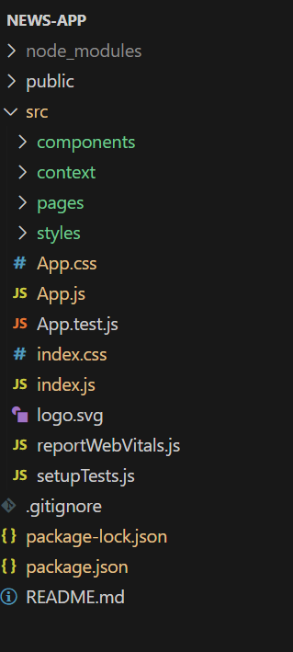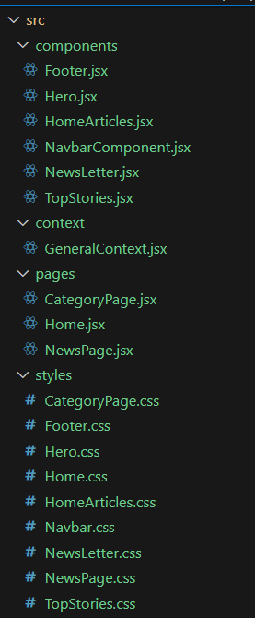

In this project, we’ve split the files into 4 major folders, *Components, Context, Pages and Styles.* In the pages folder, we store the files that acts as pages at different URLs in the application. The components folder stores all the files, that returns the small components in the application. The context Api will be coded in the context folder. All the styling css files will be stored in the styles folder.

# Project Flow:

## Project demo:

Before starting to work on this project, let’s see the demo.

Demo link: <https://drive.google.com/file/d/1i8y09FiMk7QM0akH3my10OBWqXH-8dNh/view?usp=sharing>

Use the code in:

<https://drive.google.com/drive/folders/1tDoSwd-1I3HsPJ9_92MnZTUtteeda-hL?usp=sharing>

**Milestone 1: Project setup and configuration.**

## Installation of required tools:

To build InsightStream, we'll need a developer's toolkit. We'll use React.js for the interactive interface, React Router Dom for seamless navigation, and Axios to fetch news data. For visual design, we'll choose either Bootstrap or Tailwind CSS for pre-built styles and icons.

Open the project folder to install necessary tools. In this project, we use:

* + React Js
  + React Router Dom
  + React Icons
  + Bootstrap/tailwind css
  + Axios
* For further reference, use the following resources
  + <https://react.dev/learn/installation>
  + <https://react-bootstrap-v4.netlify.app/getting-started/introduction/>
  + <https://axios-http.com/docs/intro>
  + <https://reactrouter.com/en/main/start/tutorial>

**Milestone 2: Project Development**

* Setup the Routing paths

Setup the clear routing paths to access various files in the application.

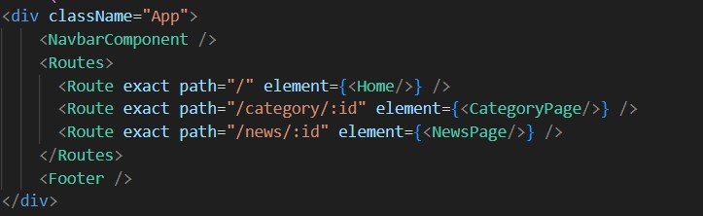

* Develop the Navbar and Hero components
* Code the popular categories components and fetch the categories from ***newsapi***.
* Also, add the trending news in the home page.
* Additionally, we can add the component to subscribe for the newsletter and the footer.
* Now, develop the category page to display various news articles under the different categories.

## Important Code snips:

**Fetching Top/Trending news**

With the API request, we fetch the trending news articles.

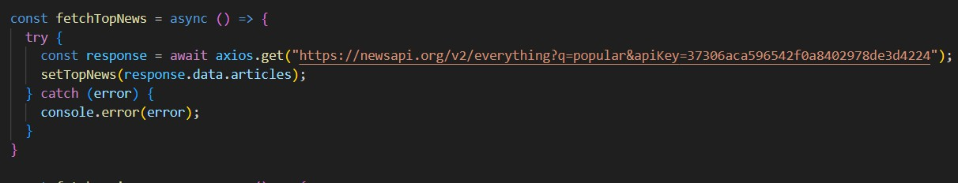

The code snippet shows a function written in Python called fetchTopNews that fetches news articles from an API. Here's a breakdown of the code:

*Async function fetchTopNews:*

The code defines an asynchronous function named fetchTopNews. An asynchronous function is used to handle asynchronous operations, such as making API requests that take time to complete.

*try...catch block:*

* + The try...catch block is used to handle the API request.
  + The try block contains the code that attempts to fetch data from the API using axios.get.
  + axios is an external Python library for making HTTP requests. If you don't already use Axios in your project, you'll need to install it using a package manager like pip.
  + The .get method makes a GET request to the specified URL.

*API URL:*

The URL used in the API request is

'[https://newsapi.org/v2/everything?q=popular&apiKey=37306aca596542f0a840297](https://newsapi.org/v2/everything?q=popular&apiKey=37306aca596542f0a8402978de3d4224) [8de3d4224](https://newsapi.org/v2/everything?q=popular&apiKey=37306aca596542f0a8402978de3d4224)'.

This is likely a specific API endpoint that returns popular news articles. You might need to replace this URL with the actual endpoint you want to use depending on the API you're using. Replace '37306aca596542f0a8402978de3d4224' with a placeholder instructing users to replace it with their own API key.

*Error Handling (catch block):*

The catch block handles any errors that might occur during the API request. If there's an error, it's logged to the console using console.error(error).

*Setting State (then block not shown):*

The .then method (not shown in the code snippet) is likely used to process the fetched data after a successful API request.

In this case, it likely updates a state variable named topNews (based on the function name fetchTopNews) with the fetched news articles. This state variable might be used to display the news articles in a user interface.

## Fetching news by search/category

With the specific category or search keyword, we use API request to fetch all the news articles related to that.

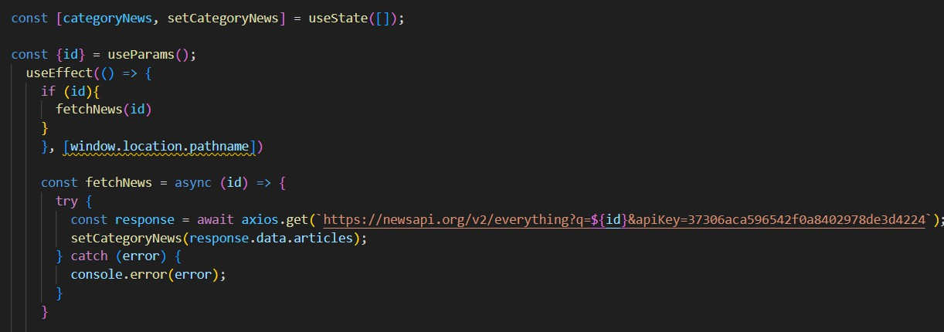

The code snippet shows a function called get_news_articles that fetches news articles from a news API. Here's a breakdown of the code:

*Imports:*

The code starts by importing the requests library. The requests library is a popular Python library for making HTTP requests. If you don't already have it installed in your project, you can install it using pip install requests.

*API Key:*

The line API_KEY = 'YOUR_API_KEY' defines a variable named API_KEY and assigns it a placeholder value 'YOUR_API_KEY'. You should replace this with a placeholder instructing users to replace it with their own API key obtained from the news API provider they want to use.

*Function Definition (get_news_articles):*

The code defines a function named get_news_articles that takes two parameters:

* + query: This parameter is likely a string representing the search query for news articles.
  + source: This parameter is likely a string representing the news source (e.g., 'bbc-news', 'cnn').

*Building the API Request URL:*

The line url = f'https://newsapi.org/v2/everything?q={query}&apiKey={API_KEY}' constructs the URL for the API request using a formatted string literal (f-string).

The URL includes the following parts:

* + - Base URL: https://newsapi.org/v2/everything
    - Query parameters:
    - q: This parameter is set to the query argument passed to the function.
    - apiKey: This parameter is set to the API_KEY variable, which should contain the user's API key.

*Making the API Request (requests.get):*

The line response = requests.get(url) sends a GET request to the API URL constructed earlier. The requests.get function from the requests library is used to make the HTTP request. The response from the API is stored in the response variable.

*Error Handling (try...except block):*

* + The try...except block is used to handle potential errors during the API request.
  + The try block contains the code that attempts to fetch data from the API using requests.get(url).
  + The except block handles any exceptions that might occur during the request, such as network errors or invalid API responses. In this case, it prints an error message to the console using print(f'Error fetching news articles: {e}').

# Project Execution:

After completing the code, run the react application by using the command “npm start” or “npm run dev” if you are using vite.js

Here are some of the screenshots of the application.

## Hero components

In the hero component, the trending news articles are displayed. It is to highlight them. Apart from that, the search bar is also available to search for various articles and categories.

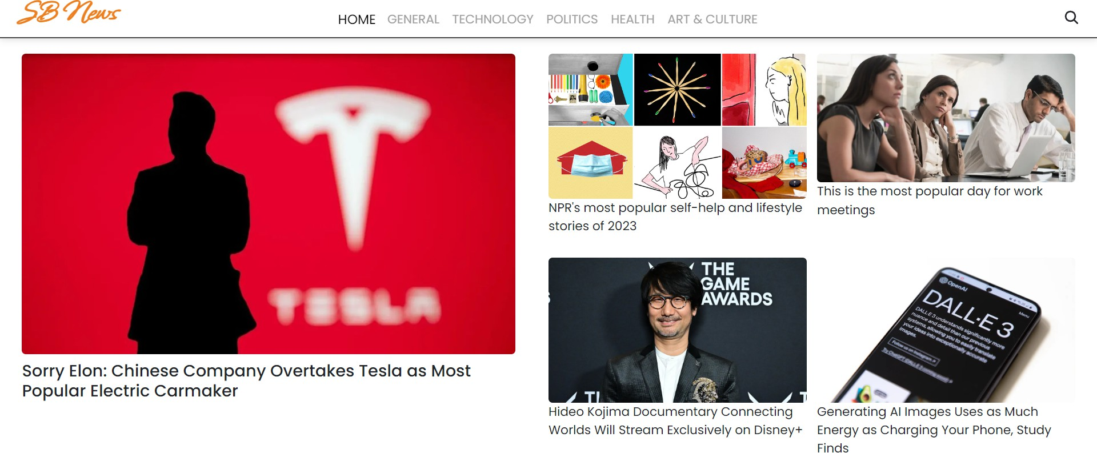

## Popular categories

In the hero component, the trending news articles are displayed. It is to highlight them. Apart from that, the search bar is also available to search for various articles and categories.

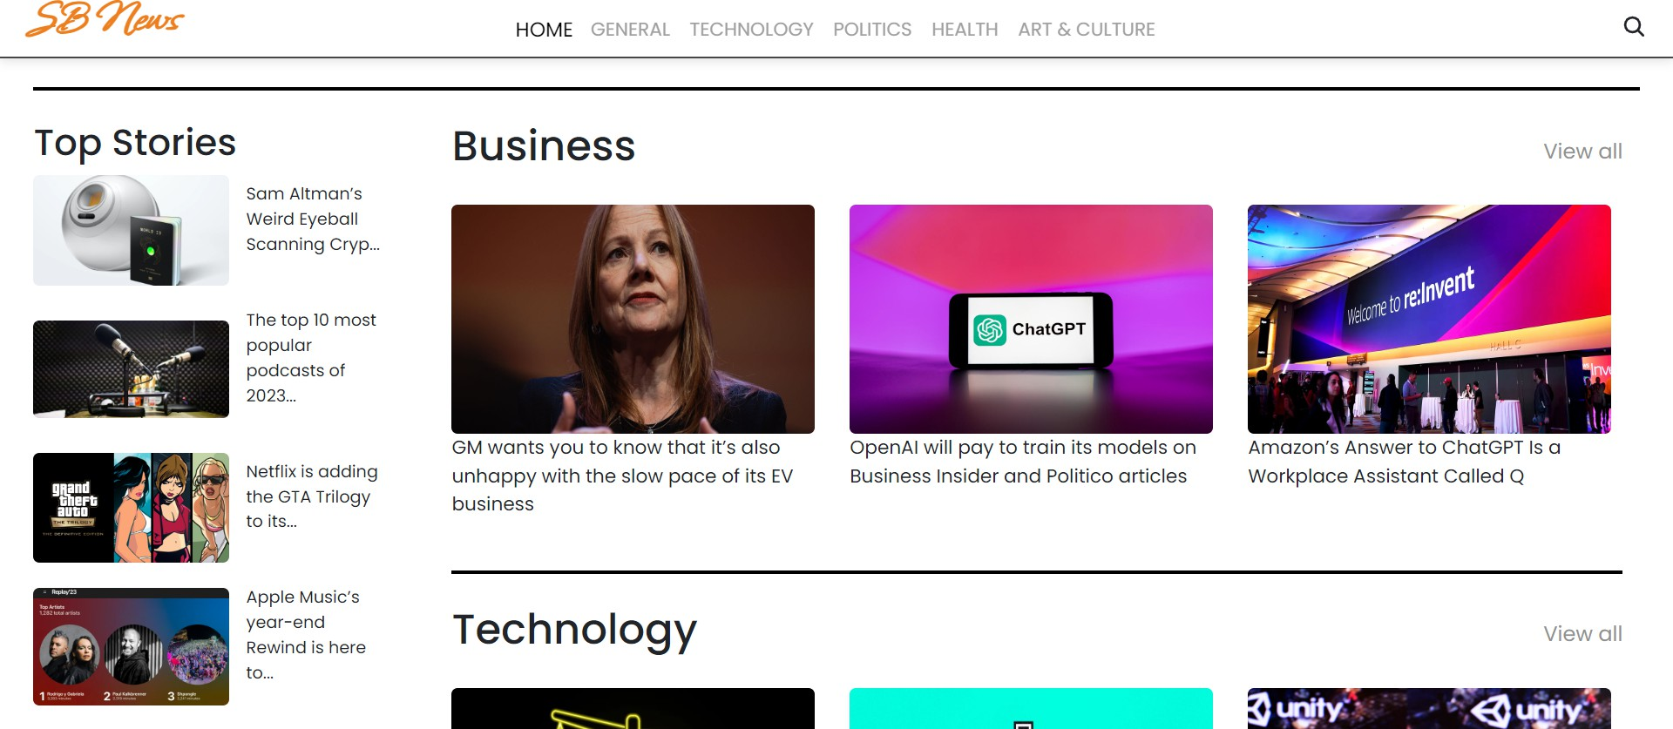

**Newsletter**

Staying informed is key! This section would act as a magnet for users who want to stay up-to-date on the latest news. A brief signup form with an email field would be presented, along with a clear call to action button like "Subscribe Now" or "Get Daily News Updates." With a simple click, users can join the InsightStream community and receive curated news delivered straight to their inbox.

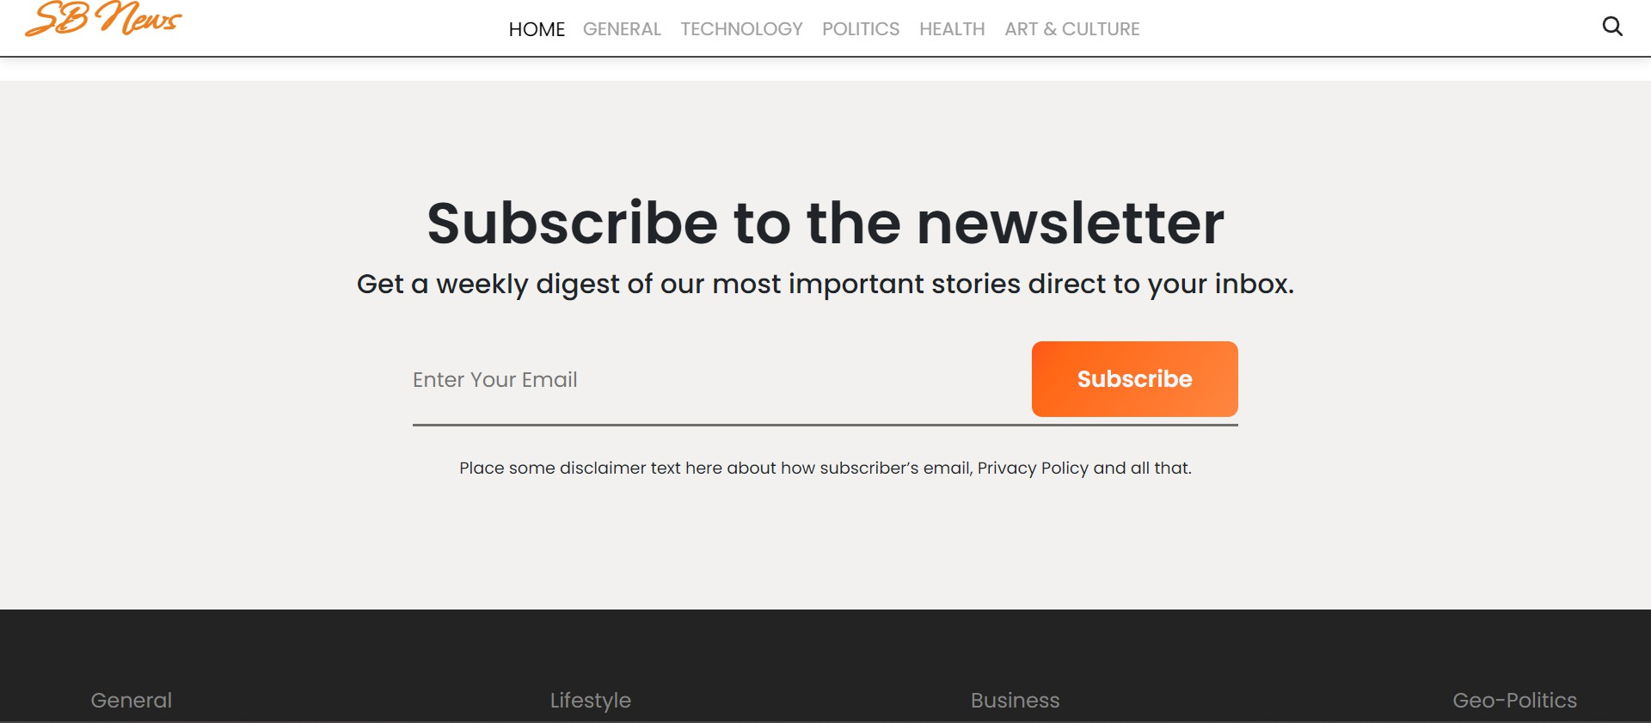

## Category/Search result page

Finding the news you crave is effortless with InsightStream. This page displays a neatly organized list of articles matching your chosen category or specific search query. Each entry would provide a clear headline, a concise summary, and if available, an image to give you a quick glimpse into the story. To further refine your exploration, filters or sorting options might be available. Imagine narrowing

down results by date, source, keyword, or other relevant criteria to pinpoint exactly what you're looking for.

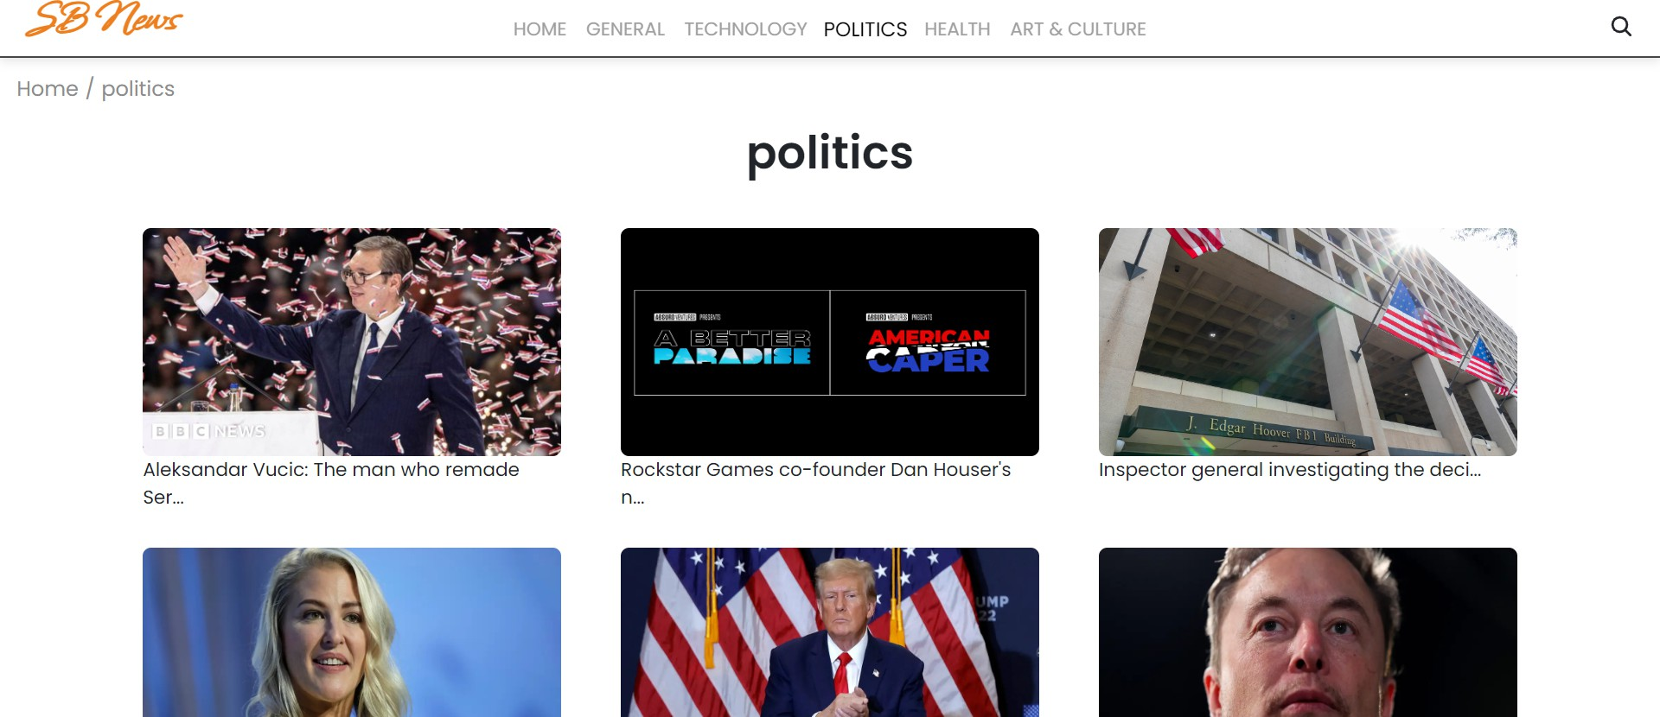

## Redirected Article page

This is where you dive deep! The article page proudly displays the complete news story, retrieved directly from the original source. To keep you engaged and exploring related topics, the page might also suggest additional articles based on the current story. These suggestions can open doors to a world of interconnected information, allowing you to become a well-rounded news connoisseur.



Project Demo link:

[https://drive.google.com/file/d/1i8y09FiMk7QM0akH3my10OBWqXH-8dNh/view?usp=shari](https://drive.google.com/file/d/1i8y09FiMk7QM0akH3my10OBWqXH-8dNh/view?usp=sharing) [ng](https://drive.google.com/file/d/1i8y09FiMk7QM0akH3my10OBWqXH-8dNh/view?usp=sharing)

**\*\*\* Happy coding!! \*\*\***